HOMEWORK 1 and 2 - Do it ASAP ! And put it on GDRIVE (your folder)

RGB+D Cameras: Image, 3D point clouds and camera model

"Kinect" (depth) cameras provide 2 type of images: RGB and DEPTH

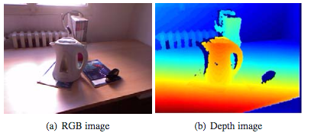

Q: What coordinate is the "depth" ? How is it obtained ?

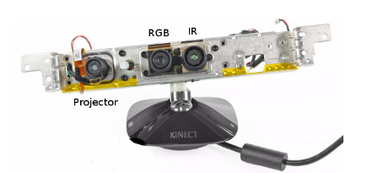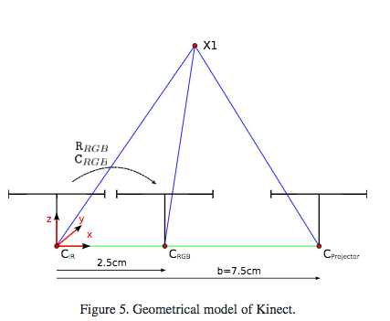

Tasks:
- See RGB and Depth images
  - display and interpret images
  - display R,G,B in separate figures
- Display depth
  - depth as image
  - depth as a surface
  - point cloud, mesh
  - depth image vs. point cloud

Dataset:
Load depth image from the lab (link)
read image from file (link)
load point cloud (link)
http://printart.isr.ist.utl.pt/piv/lab/pivlab1/

Remember what you learned in class about the pin-hole camera model:

Camera model -
- How to generate an image from 3D points?
- How to compute 3D positions from images/depth

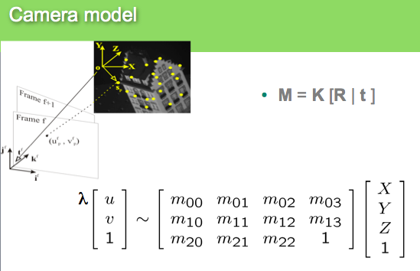

TODO (Task 1): image from 3D world
- Load file points3D.mat
- execute the command showPointCloud(pc) and check that you understand what is being displayed
- from variables xyz (a point cloud) and the corresponding rgb values for each point, create the corresponding image: from (1) create (2)
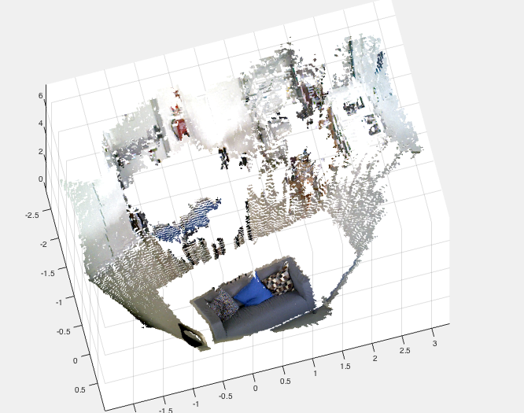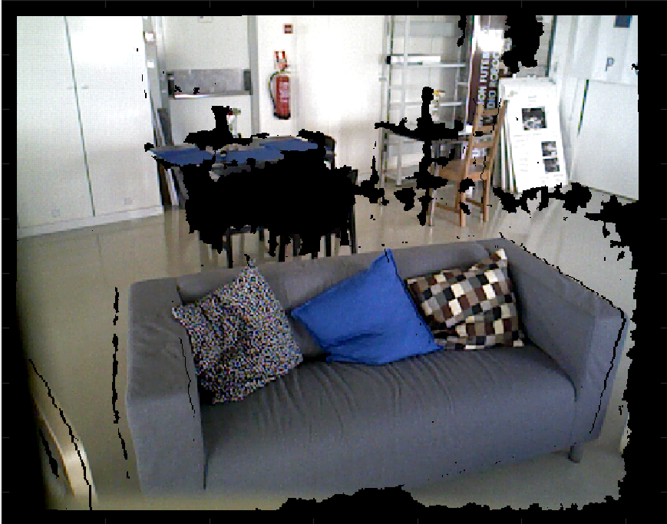
TODO (Task 2): From rgb&Depth create 3D point cloud
- given the depth image compute XYZ
- Rotate and Translate point cloud and represent XYZ in the rgb camera frame
- Create a “virtual” depth image in the RGB camera frame
- Associate xyz/Depth values to RGB pixel

In other words …
From these two images

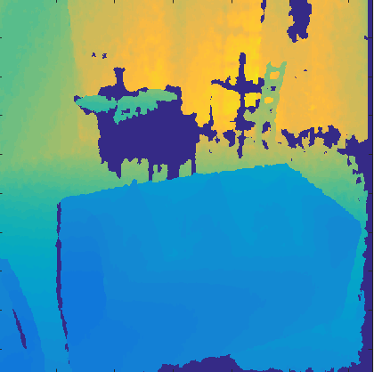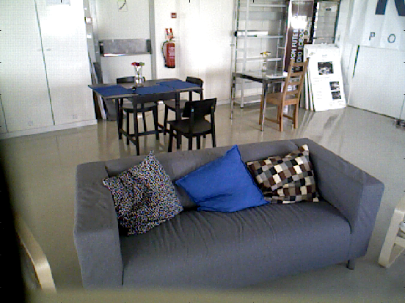

and the intrinsic and extrinsic camera parameters you should be able to "superimpose" the depth over the rgb:

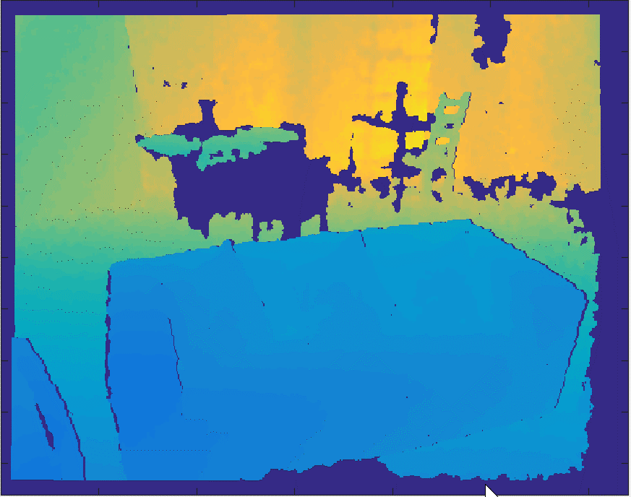

Note that now each pixel of this image is in line with the depth! So, you can compute XYZ for each pixel and create this point cloud

LAB Topic (Homographyes)

Remember the image transformation list from the lectures.
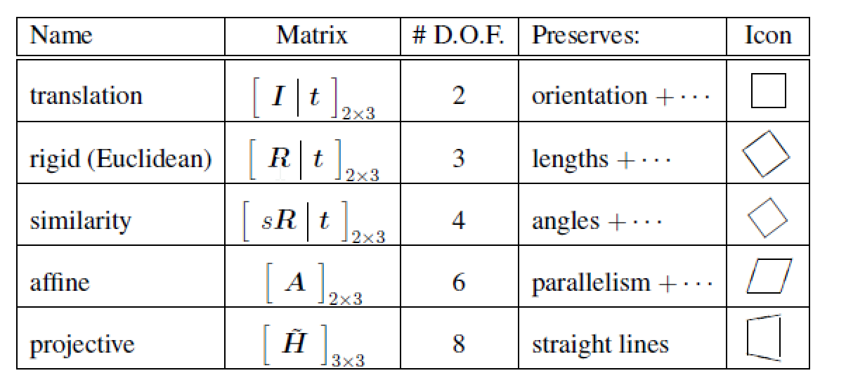

Refer to Image transformations (page 35) and 2D alignement (pg 312) Szelisky’s book and slides from class.

Most general projection (projective) is
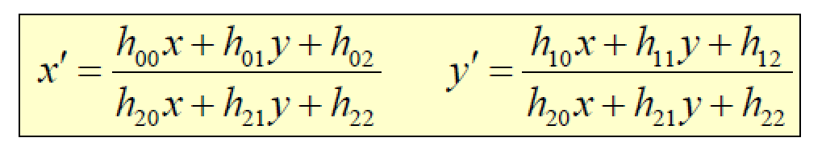
How to estimate parameters hii and … which transformation to select ?

Given these 4 matches , how can we generate a frontal view ? Take notes from the board (in class) ! We will run the code in map_homography.m

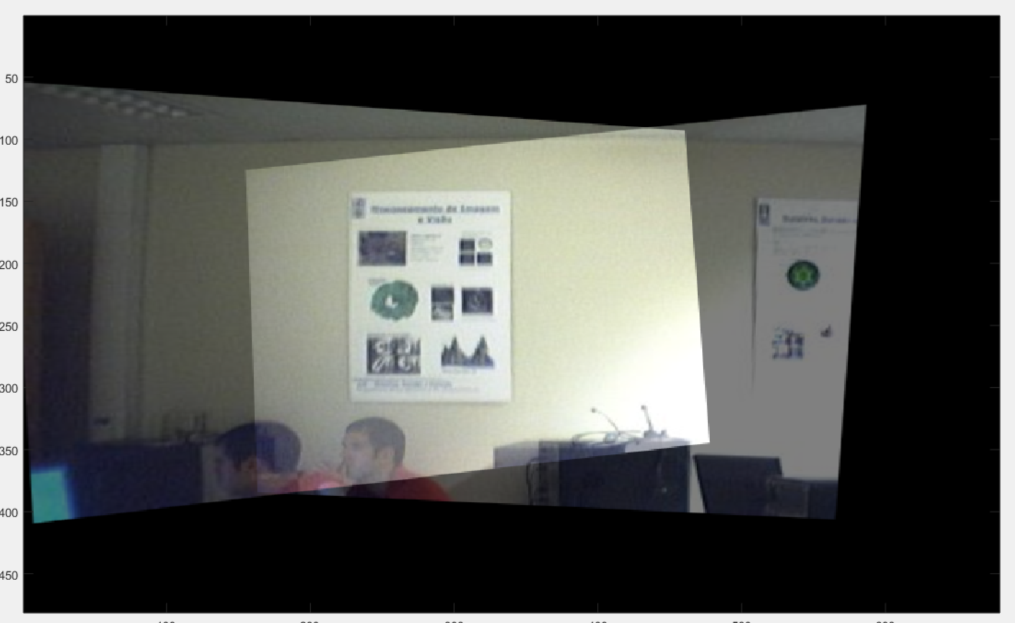

Compute homography H1 and H2 and fuse both images

parede1=imread('parede1.jpg');
parede2=imread('parede2.jpg');
%lab2 feito pelo nuno
imshow(parede1);
[u1 v1]=ginput(4);
figure;
imshow(parede2);
[u2 v2]=ginput(4);

pts=[0 0; 200 0; 200 300; 0 300];%assign coordinates for the points %in the frontal view! Why ? What else could be done ?????Are these %points unique…arbitray ????
t1=cp2tform([u1 v1],pts,'projective');
t2=cp2tform([u2 v2],pts,'projective');

im1=imtransform(parede1,t1,'Xdata',[-400 800],'YData',[-250 600]);
im2=imtransform(parede2,t2,'Xdata',[-400 800],'YData',[-250 600]);

See also Linear Least Squares (DLT) – review equations we saw in the class (and how cp2tform works)

How to find points and match them automatically ?

For now you can admit this process is “solved”, using feature detectors (SURF, SIFT or any other). Matlab has SURF built in but you can use SIFT (check theoretical class). Particularly there is a toolbox you can use http://www.vlfeat.org

---------------

LAB Topic: RANSAC

LAB Topic: 3D point cloud registration and feature matching

Objective:
- How to register 2 point clouds
- Procrustes problem
- How to match 2 images and compute 3D transformation using depth info

So, Given 2 rgb images

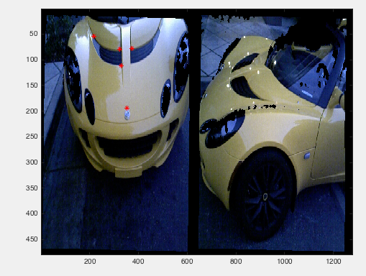

and 2 depth images

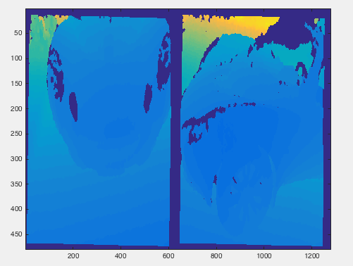

We can compute the 3D point clouds in each camera as we saw last class
3D point cloud from image 1-
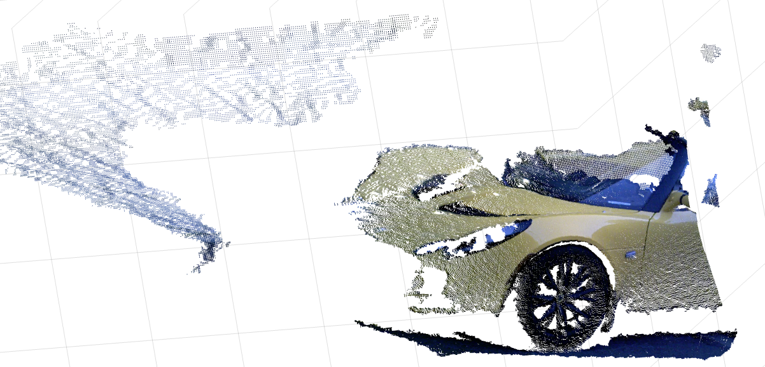
3D point cloud from image 2
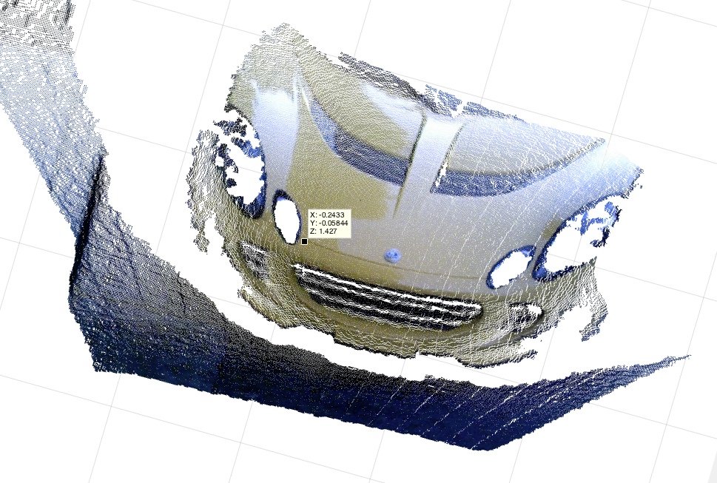

QUESTION: How can we fuse both point clouds?
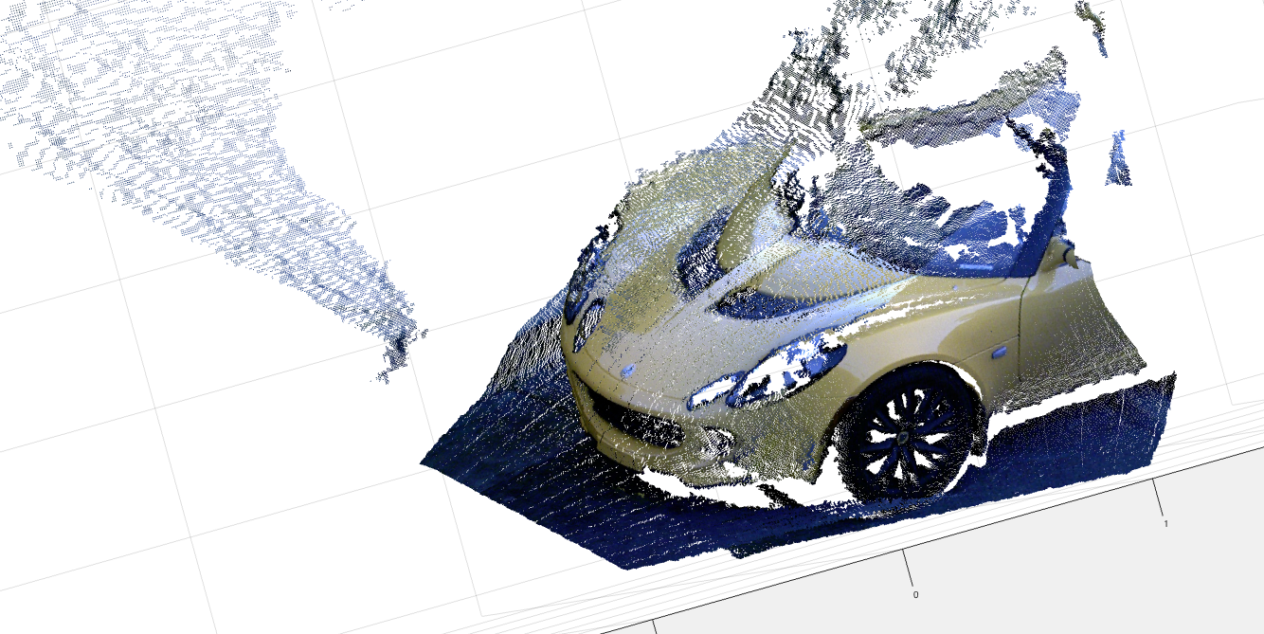

What has to be done:
READINGS: Very important that you read this article

D.W. Eggert, A. Lorusso, R.B. Fisher, Estimating 3-D rigid body transformations: a comparison of four major algorithms, Machine Vision Applications, 1997

- Match points between images
- Compute xyz from these matches
- Compute Rotation and Translation from pairs of 3D points

-HOMEWORK -

CHALLENGE 1
Click in one (or more) points in image 1 (red dots) and
Predict where these points are located in image 2 (yellow dots). You have to use the intrinsics for depth and rgb as well as the extrinsics between both "cameras".
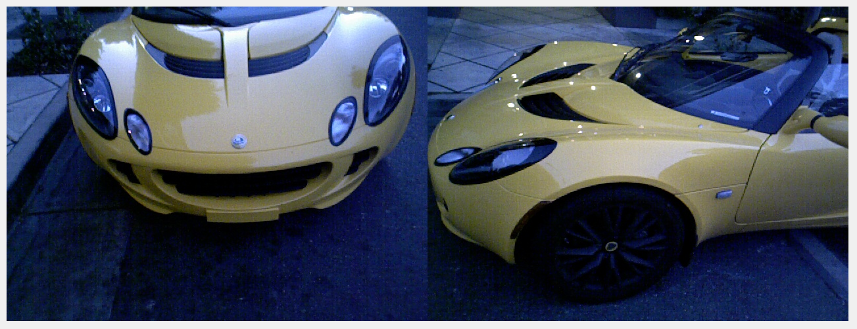

CHALLENGE 2
Consider now a third image without common points with image 1
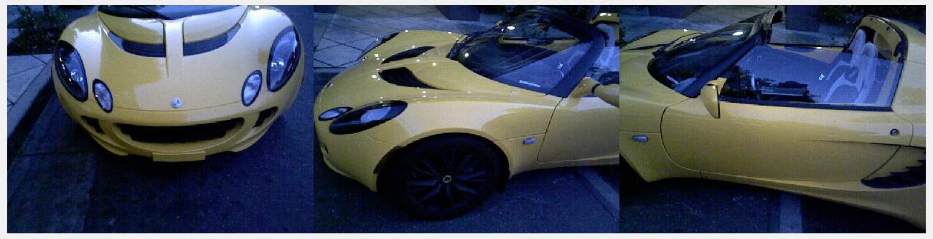
image 1 image 2 image 3
Using the depth image 3 (and the point cloud)
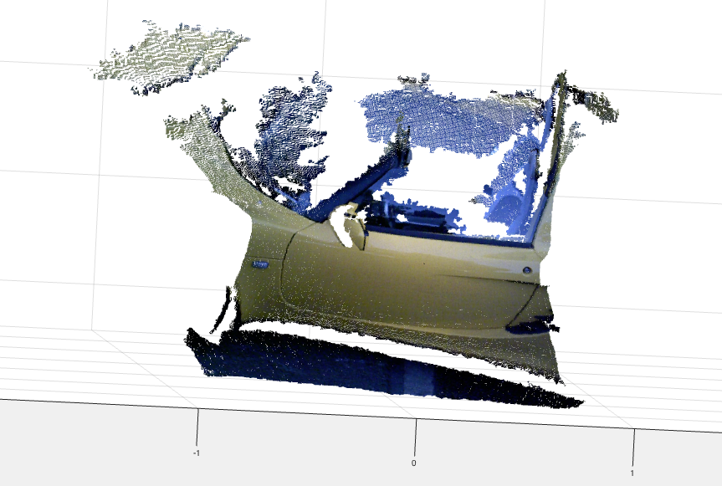

Fuse all 3 images !
AND YOU WILL BE ALMOST DONE WITH PART 2 !
This is what you will get :-)
